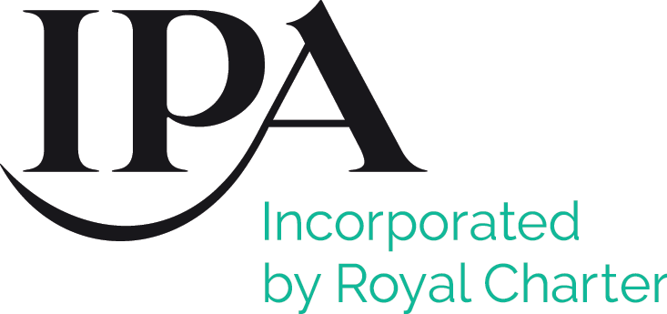 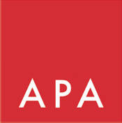



**Production Conduct Initiative**

Advertising productions bring together temporary teams of both staﬀ and freelance individuals from several organisations in circumstances that can be unusual and intense.

Everyone involved in our productions is entitled to a professional setting where they can do their best work.

Everyone (meaning individuals and organisations) participating in productions should always provide a safe and respectful environment for all those involved - free from any form of bullying, harassment or discrimination.

Organisations entering into productions should ensure that their own policies and procedures are clearly communicated and robust, enabling them to deal promptly and eﬀectively with complaints raised by any individuals working on productions against other individuals for whom those organisations have

responsibility. They should consider industry dignity at work initiatives, such as, for example, the #timeTo Code of Conduct (timeto.org.uk).

Initiatives like #timeTo are supported by the APA, the IPA, and ISBA.

Adherence to, and awareness of industry conduct initiatives could, as appropriate, be bound into productions through the PIBS Agreement, PPM documents and call sheets.

Please see appendix for templates.



# Appendix 1

## Template slide for PPM document



 



This project is being produced in accordance with the APA/IPA/ISBA Production Conduct Initiative.

Parties to this PPM should discuss and agree that:

*“Advertising productions bring together temporary teams of both staﬀ and freelance individuals from several organisations in circumstances that can be unusual and intense.*

*Everyone involved in our productions is entitled to a professional setting where they can do their best work.*

*Everyone (meaning individuals and organisations) participating in productions should always provide a safe and respectful environment for all those involved - free from any form of bullying, harassment or discrimination.*

*Organisations entering into productions should ensure that their own policies and procedures are clearly communicated and robust, enabling them to deal promptly and eﬀectively with complaints raised by any individuals working on productions against other individuals for whom those organisations have responsibility.”*

Parties to this PPM should conﬁrm that they have suitable policies and procedures in place to align with the Initiative and they should include Production Conduct Initiative Appendix 2 in call sheets for the shoot, including any speciﬁc details of the senior representatives for each organisation.



# Appendix 2

## Template slide for call sheets



 



This project is being produced in accordance with the APA/IPA/ISBA Production Conduct Initiative, which states:

*“Advertising productions bring together temporary teams of both staﬀ and freelance individuals from several organisations in circumstances that can be unusual and intense.*

*Everyone involved in our productions is entitled to a professional setting where they can do their best work.*

*Everyone (meaning individuals and organisations) participating in productions should always provide a safe and respectful environment for all those involved - free from any form of bullying, harassment or discrimination.*

*Organisations entering into productions should ensure that their own policies and procedures are clearly communicated and robust, enabling them to deal promptly and eﬀectively with complaints raised by any individuals working on productions against other individuals for whom those organisations have responsibility.”*

If you want to make a complaint or have a concern or query relating to misconduct, please speak to the senior representative of your organisation on this production.

For example:

* Client brand personnel  chief marketing oﬃcer
* Advertising agency personnel and cast  head of production
* Production company personnel, including production, director, crew, suppliers managing director/head of production

For independent, conﬁdential advice and support for anyone working on this production, call the National Advertising Benevolent Society (NABS) advice line on: 0800 707 6607 (9am – 5.30pm) or email: [support@nabs.org.uk.](mailto:support@nabs.org.uk)

In an emergency (where you or anyone else is in imminent danger or at risk of serious harm), please call the emergency services.



# Appendix 3

## Template text for PIBS Section J – Additional Contractual Requirements



 



The Agency and Production Company agree that they each have and shall maintain in place adequate policies and procedures that enable them to deal promptly and eﬀectively with any complaints involving bullying, harassment or discrimination raised by any individuals working on, or otherwise involved with, the Production against other individuals working on, or otherwise involved with, the Production and in respect of whom they have responsibility. They also agree that they are aware of and adhere to industry initiatives intended to protect the well-being and safety of all individuals working on productions.

